**1.** Design a 1-bit subtraction circuit, with $C_{i}$ is input borrow signal, $C_{o}$ is output borrow signal and a control input P. Where: $P=0$, output $Y=A-B$; else $Y=B-A$.

**2.** Using the result of problem 1, design a 3-bits subtraction circuit with control P.

**3.** Design a logic circuit with output F depends on 4 inputs (let say A, B, C, D). F will HIGH if number of bit 1 greater than 0, otherwise F will LOW.

**4.** Given that: $F=AB+BC+CA$. Design a logic circuit to implement function F using:

a) 1 IC 74138 (Decoder 3 $→$ 8) and 1 4-inputs logic gate.

b) 1 IC 74135 (Mux 4 $→$ 1).

c) 2 Half Adder and 1 2-inputs OR gate.

**5.** A 4-bits binary number is represented as DCBA, where D, C, B, A represent the individual bits and A is LSB. Design the logic circuit that produce a HIGH level of output whenever the binary number is greater than or equal 0110 and less than 1010.

**6.** Using IC 7490 design a counter:

a) MOD 58.

b) MOD 68.

c) MOD 69.

d) Count form 0 to 71.

**7.** Convert Flip Flop.

a) D-FF to JK-FF and reverse.

b) D-FF to T-FF and reverse.

c) T-FF to JK-FF and reverse.

**8.** In a simple copy machine, a stop signal S is to be generated to stop the machine’s operation and energizing an indicator light whenever either of the following condition exists: (1) There is no paper in the paper feeder tray or (2) the two micro switches in the paper path is activated, indicating a jam in the paper path. The presence of paper in the feeder tray is indicated by a HIGH at logic signal P. Each of the micro switches produces a logic signal (Q and R) that goes HIGH whenever a paper is passing over the switch to activate it. Design the logic circuit to produce a HIGH at output signals for the stated condition and implement it using 2-inputs NAND gates only.

**9.** Given the logic circuit.

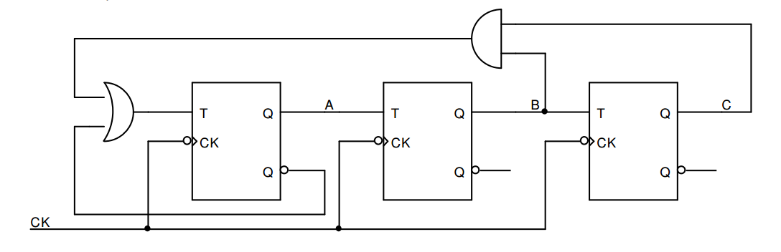

a) Analyze the logic circuit.

b) What type of this circuit? Can the circuit is self-working?

c) Build the state diagram if initial states of ABC are 110.

**10.** Given the JK FF has the following wave form of input. Sketch the output signal.

